Project 1

Mastermind Game

CSC 5 46023

Name: David Snow

Date: 7/20/14

**Table of Contents**

**Table of Contents** ...................................................................................................................... 2

**1- Introduction** ............................................................................................................................ 3

Gameplay and Rules ...........................................................................................................

**2- Summary** …………………………………………………………………………………………………………………………… 3

Lines of code

Variables

Difficulties

**3- Description** ............................................................................................................................. 3

**4- Flowchart** ................................................................................................................................ 4

**5- Pseudo-Code** ........................................................................................................................... 5

**6- Research** …………………………....................................................................................................... 6

**7- Variable Types and topics** ........................................................................................................ 6

**Variable names**

**8- Actual Code** ……………………........................................................................................................ 6

**Introduction**

Name of the game: Mastermind

Mastermind is a code solving game that requires a player to guess what the code is with several clues upon the way.

For example, the code could be 4 – 2 – 1 -3 and your guess could be 1 – 4 – 3 – 2.

I modified the game slightly so it does not tell you if a number of the guess is in the wrong area of the code. If the code is solved, you win.

**Summary**

Size of code: 190 lines

Number of variables: 12 variables

Number of methods: 7

This project included many of the topics discussed so far in class. It also has the potential to be expanded on for next project. Like adding in the code for if a guess was out of place. This project took a while because I was having difficulty deciding how to input certain topics such as floats and the switch statement.

**Description**

The main point of the program I coded was If-else-if statements.

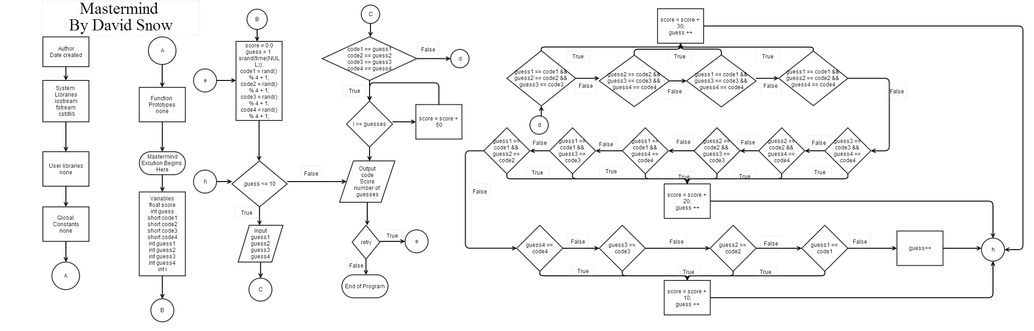**Flow Chart**

**Pseudo code**

Execution Starts Here!

Variables

Score counter

Number of guesses allowed

Code to guess variables

Guess variables

File variable

Retry variable

Pre - variable inputs

Random code generator

Input guesses for code

Determining how many are correct and score they receive

Determining if you lose

Retry

**Research**

"Random number generator." - C++ Articles. 21 July 2014. Web. <http://www.cplusplus.com/articles/EywTURfi/>.

**Variable Names**

|  |  |
| --- | --- |
| **Float: score** | **Score tracker** |
| **Int: guess** | **Number of guesses** |
| **Char: redo** | **Retry variable** |
| **Int: guess1** | **First number of guess** |
| **Int: guess2** | **Second number of guess** |
| **Int: guess3** | **Third number of guess** |
| **Int: guess4** | **Fourth number of guess** |
| **Short: code1** | **First number of code** |
| **Short: code2** | **Second number of code** |
| **Short: code3** | **Third number of code** |
| **Short: code4** | **Fourth number of Code** |
| **Int: i** | **For the for loop only** |

**Variables types and Topics**

|  |  |
| --- | --- |
| File input variable | Line 36 |
| File open | Line 72 |
| Output to file | Line 74 |
| File close | Line 75 |
| random | Line 45 |
| switch | Line 80 |
| if | Line 173 |
| Else if | Line 97 |
| If Else | Line 73 |
| Do While | Line 39 |
| While | Line 49 |
| float | Line 23 |
| Int | Line 24 |
| Short | Line 26 |
| Char | Line 38 |
| Cout | Line 51 |
| Cin | Line 52 |
| For | Line 68 |

**Actual Code**

//system libraries

#include <iostream>

#include <cstdlib>

#include <fstream>

using namespace std;

//User Libraries

//Global Constants

//Function Prototypes

//Execution Starts Here!

int main(int argc, char** argv) {

//variables

float score; //score counter

int guess; //number of guesses allowed

//code to guess variables

short code1;

short code2;

short code3;

short code4;

//guess variables

int guess1;

int guess2;

int guess3;

int guess4;

//file variable

ifstream output;

//retry variable

char redo;

do{

//pre - variable inputs

score = 0.0;

guess = 1;

//random code generator

srand(time(NULL));

code1 = rand() % 4 + 1;

code2 = rand() % 4 + 1;

code3 = rand() % 4 + 1;

code4 = rand() % 4 + 1;

while (guess <= 10){

//input guesses for code

cout << "Input the first number you guess:(1-4) ";

cin >> guess1;

cout << "Input the second number you guess:(1-4) ";

cin >> guess2;

cout << "Input the third number you guess:(1-4) ";

cin >> guess3;

cout << "Input the fourth number you guess:(1-4) ";

cin >> guess4;

//determining how many are correct and score they receive

if (guess1 == code1 && guess2 == code2 && guess3 == code3

&& guess4 == code4){

cout << code1 << " ";

cout << code2 << " ";

cout << code3 << " ";

cout << code4 << endl;

cout << "All positions are correct. You Win!!! " << endl;

cout << "It took you " << guess << " guesses. " << endl;

for(int i = 10; i >= guess; i--){

score = score + 50.0;

}

cout << "Your score is " << score << endl;

output.open ("Score.txt");

if (output.is_open()){

output >> score;

output.close ();

}

else{

cout << "The file is not open.";

}

switch (guess){

case 1:

case 2:

case 3:

case 4:

case 5:

cout << "Congratulations!! You got it in half or"

" less of the number of guesses allowed" << endl;

default:

;

}

break;

}

else if (guess2 == code2 && guess3 == code3 && guess4 == code4){

cout << "Three guesses are correct " << endl;

score = score + 30.0;

guess ++;

}

else if (guess1 == code1 && guess3 == code3 && guess4 == code4){

cout << "Three guesses are correct " << endl;

score = score + 30.0;

guess ++;

}

else if (guess1 == code1 && guess2 == code2 && guess4 == code4){

cout << "Three guesses are correct " << endl;

score = score + 30.0;

guess ++;

}

else if (guess1 == code1 && guess2 == code2 && guess3 == code3){

cout << "Three guesses are correct " << endl;

score = score + 30.0;

guess ++;

}

else if (guess3 == code3 && guess4 == code4){

cout << "Two guesses are correct " << endl;

score = score + 20.0;

guess ++;

}

else if (guess3 == code3 && guess4 == code4){

cout << "Two guesses are correct " << endl;

score = score + 20.0;

guess ++;

}

else if (guess2 == code2 && guess4 == code4){

cout << "Two guesses are correct " << endl;

score = score + 20.0;

guess ++;

}

else if (guess2 == code2 && guess3 == code3){

cout << "Two guesses are correct " << endl;

score = score + 20.0;

guess ++;

}

else if (guess1 == code1 && guess4 == code4){

cout << "Two guesses are correct " << endl;

score = score + 20.0;

guess ++;

}

else if (guess1 == code1 && guess3 == code3){

cout << "Two guesses are correct " << endl;

score = score + 20.0;

guess ++;

}

else if (guess1 == code1 && guess2 == code2){

cout << "Two guesses are correct " << endl;

score = score + 20.0;

guess ++;

}

else if (guess4 == code4){

cout << "One guess is correct " << endl;

score = score + 10.0;

guess ++;

}

else if (guess3 == code3){

cout << "One guess is correct " << endl;

score = score + 10.0;

guess ++;

}

else if (guess2 == code2){

cout << "One guess is correct " << endl;

score = score + 10.0;

guess ++;

}

else if (guess1 == code1){

cout << "One guess is correct " << endl;

score = score + 10.0;

guess ++;

}

else{

cout << "No guess is correct" << endl;

guess ++;

}

}

//determining if you lose

if (guess == 11){

cout << "You lose!!!" << endl;

cout << "Number of guesses was 10." << endl;

cout << "Better luck next time." << endl;

cout << "Your score is " << score << endl;

}

//Retry

cout << "Retry? Y/N ";

cin >> redo;

}while (redo == 'y' || redo == 'Y');

return 0;

}